PARAM: The First Super Computer of India

Avishek Bhattacharjee

Department of ECE

HETC, Hooghly, WB, India

[wbavishek@gmail.com](mailto:wbavishek@gmail.com); [wbavishekbhattacharjee@gmail.com](mailto:wbavishekbhattacharjee@gmail.com)

*Abstract:* The Super Computer changes the world with its amazing features. Generally, in each developed country, there is one supercomputer, which is the backbone of the country. For all types of research, super computers are very useful, as well as for carrying out a variety of tasks in different fields like corps, weather departments, and also in satellite departments. PARAM (Parallel Machine) is the first super computer in India that changes Indian technology with its myriad features. In this paper, the history, architecture, and development of PARAM have been discussed in an elegant way.

*Keywords:* C-DAC, PARAM Yuva, PARAM Shavak, INMOS Transputer, Mflops, Gigaflops, GARUDA, HPC, MPP.

1. Introduction

India had intentions to purchase a super computer from the USA in the middle of the 1980s to be used for weather forecasting, however the sale of the super computer to India is said to have been cancelled. At the time, India was having difficulties performing scientific and defence-related operations properly, so scientists were hoping for a native-based solution that would provide the same gratification as a supercomputer. Therefore, C-DAC [1] was made and PARAM 8000, the first super computer in India, was introduced. It is the classical distributed memory multiprocessor system with highest performance. After a series of PARAM were developed to enhance and improve compliance with standards, PARAM was created with low costs and high performance computing (HPC [8]) in mind. The architecture of the PARAM series has been altered to more efficiently handle multiple issues at once. As it advances, the solution is being reached day by day. It will continue to alter as technology advances both now and in the future. India recently awarded French technology firm *Atos* the contract to build a network of 70 supercomputers across India under the National Supercomputing Mission.

2. History of Supercomputer and its processors

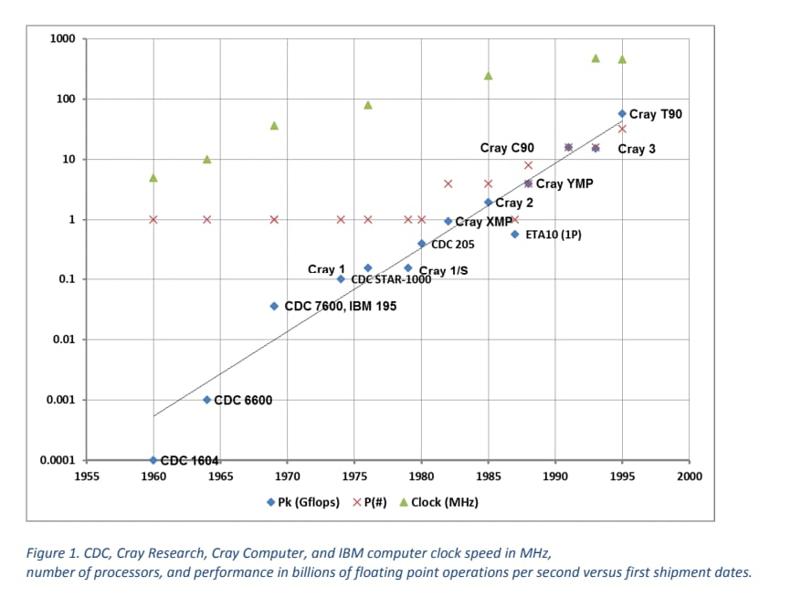Seymour Cray established supercomputing for thirty years in 1964 with the delivery of the Control Data Corporation's CDC 6600 to the Lawrence Livermore National Laboratory. CDC 6600 is considered as the World first super computer somehow. The evolution of supercomputer includes 4 stages those are Budded stage (1960-75), Vector stage (1976-87), MPP [9] Stage (1987-2000), Cluster Stage (2000-10). The Cray Y-MP, a 1988 invention from Cray Research, had up to eight 167MHz, 32-bit vector processors. It had options for 128, 256, or 512MB of SRAM main memory and was the first supercomputer to sustain greater than 1 Gigaflops [6] (109 floating point operations per second). Cray launched the T3D in 1994. It integrated 64-bit DEC Alpha 21064 RISC chips as its processor elements (PEs), ranging in size from 32 to 2,048 in total. The chip contained a dedicated pre-fetch queue, memory controller, and memory area. The PEs were arranged in nodes of six chips or in pairs. Cray’s last major new vector processing system, the T90, first shipped in 1995. Overall, supercomputer processors also had some good clock speed gains during this time. In terms of architecture, Cray and NEC had turned toward distributed parallel systems connected with a high-performance network. The SGI systems were SMP, and both Cray and NEC had parallel SMP systems. In the early 2000s, SGI released the Origin 3000 with a new version of the MIPS R10000 processor. The R12000 was an improved R10000 and ran up to 360MHz. However, NEC created a special version called the Earth Simulator that had 640 nodes. The Earth Simulator was the fastest supercomputer for a considerable time.

Government of India sets up Central for Development of Advanced Computing in 1988. In July 1991, with mission effort of 300 man-years, PARAM 8000 was delivered. The IIT Kharagpur is the first academic institution to get a super computing facility under the *National Supercomputing Mission (NSM).*

3. Development of PARAM over the Years

*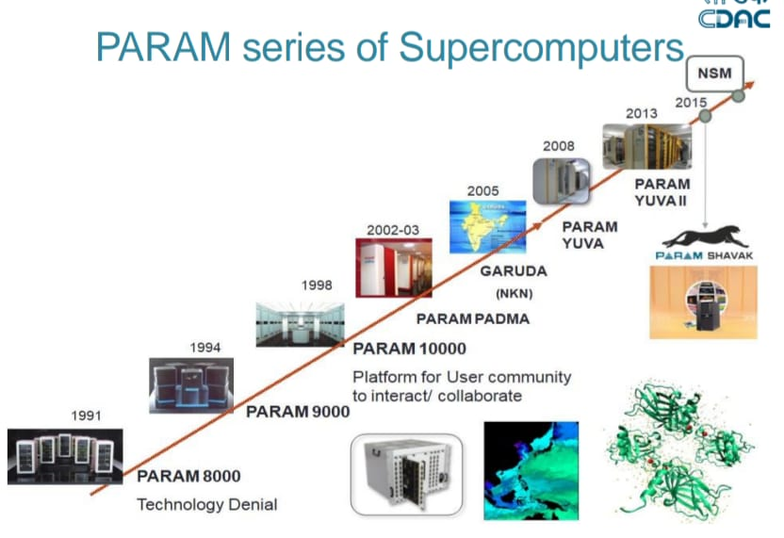*A series of PARAM had been developed by the C-DAC after the first launching of PARAM 8000. These are,

* PARAM 8000 (1991)
* PARAM 8600 (1992)
* PARAM 9000 (1994)
* PARAM 10000 (1998)
* PARAM PADMA (2002)
* PARAM YUVA (2008)
* PARAM YUVA II (2013)
* PARAM SHAVAK (2015)
* PARAM ISHAN (2016)
* PARAM BRAHMA (2018)
* PARAM SIDDHI-AI (2019-21)

However, supercomputers were being challenged by massively parallel systems, and many times the manufacturers were creating their own processors. All eventually switched to workstation processors.

1. *PARAM 8000:* The PARAM 8000 was the first device made from the ground up. It included 64 nodes constructed on a distributed memory MIMD (Multiple Instruction, Multiple Data) architecture, in which each CPU has its own memory location. INMOS [4] T800/T805 transputers [5] were employed by each node. The theoretical performance of this 256-node system was 1 Gigaflops, but in reality it is only 100–200 Mflops [6].
2. *PARAM 8600:* A better version of PARAM 8000 called PARAM 8600 was unveiled in 1992. The Intel i860 CPU was something C-DAC wished to use for added power. As powerful as four PARAM 8000 clusters, each 8600 cluster.
3. *PARAM 9000:*The PARAM 9000, which combines workloads for cluster processing and massively parallel processing, was initially shown in 1994. Utilizing the Clos network design, this system expanded up to 200 CPUs with 32–40 processors. The PARAM 9000/SS used a SuperSPARC II CPU, while the PARAM 9000/US and PARAM 9000/AA used UltraSPARC and DEC Alpha processors, respectively.
4. *PARAM 10000:* The PARAM 10000 was revealed in 1998. This supercomputer had independent nodes, each based on the Sun 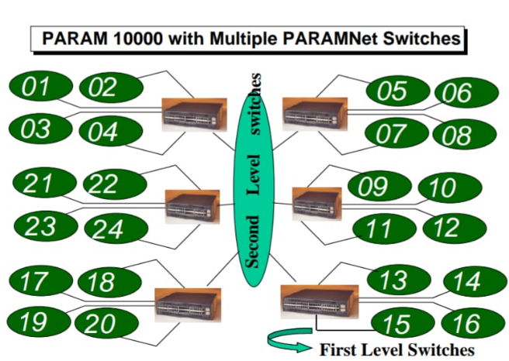Enterprise 250 server; each server contained two 400 Mhz UltraSPARC II processors. The maximum speed of this system was 6.4 Gflops. This would contain 160 CPUs and be capable of 100 Gflops, easily scalable to the Tflop range. PARAM 10000 is based on cluster of SMPS, replicated UNIX OS.
5. *PARAM YUVA:* The PARAM Yuva supercomputer, which was announced in November 2008, came in at number 69 in the Top 500 list of supercomputers worldwide. The maximum sustained speed (Rmax) and the highest speed (Rpeak) of this supercomputer are 38.1 Tflops and 54 Tflops, respectively. It utilised PARAMNet-3 as its main connection and had a storage capacity ranging from 25 TB to 200 TB.
6. 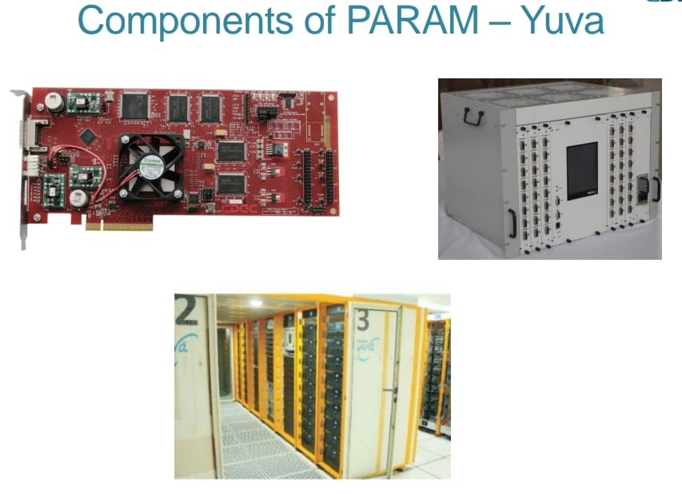*PARAM YUVA II:* The launch of PARAM Yuva II occurred in February 2013. It cost 160 million to produce and took three months to complete. It will use 35% less energy than the current facility while performing at a peak of 524 Tflops, which is roughly ten times quicker. The supercomputer can consistently achieve 360.8 Tflops on the widely used LINPACK benchmark, according to CDAC. More than 500 Teraflops was the performance target for this Indian supercomputer.
7. *PARAM SHAVAK:* A supercomputing-in-a-box solution called PARAM Shavak is table top-based and does not require a data centre ecosystem. It is the appropriate solution for both personal supercomputing and training because of the design's small nature, which permits a perfect link between HPC requirements and available infrastructure.
8. *PARAM ISHAN:* PARAM-ISHAN was unveiled in September 2016 as a 250 Teraflops capacity hybrid HPC at IIT Guwahati.
9. *PARAM BRAHMA:* PARAM Brahma is supported by a unique cooling system called direct contact liquid available in India. As of 2020, this supercomputer is available at IISER Pune. This supercomputer had a computational power of 850 Teraflops with 1 PetaByte storage capacity.
10. *PARAM SIDDHI-AI:* The fastest supercomputer created in India, PARAM Siddhi-AI, is a high-performance computing-artificial intelligence (HPC-AI) system with a Rpeak of 5.267 Pflops and a Rmax of 4.6 Pflops (Sustained).

4. Conclusion

In the final section of this project, you can watch how speed improves from Gflops to Pflops day by day as technology progresses. Technology today is dependent on artificial intelligence, hence PARAM Siddhi-Ai is the series' most recent upgrade. If India intends to make substantial strides in fields like weather forecasting, drug development, astrophysics, and bioinformatics, high-performance computing is important. In addition to reducing India's reliance on imports, favourable conditions and financing in the sciences and technologies will support its Make in India initiative.

References

* A Case for PARAM Shavak: Ready-to-Use and Affordable Supercomputing Solution; Sandeep Agrawal; Shweta Das; Manjunatha Valmiki; Sanjay Wandhekar; Rajat Moona and others
* Indian science, technology, and society: the changing landscape; RA Mashelkar - Technology in society, 2008 – Elsevier
* Experimental seasonal forecast of monsoon 2005 using T170L42 AGCM on PARAM Padma; JV Ratnam, DR Sikka, A Kaginalkar, A Kesarkar… - Pure and Applied …, 2007 – Springer
* Experimental Seasonal Forecast of Monsoon 2005 Using T170L42 AGCM on PARAM Padma J. Venkata Ratnam1, DR Sikka2, Akshara Kaginalkar1, Amit S Banerjee – Citeseer
* Global spectral medium range weather forecasting model on PARAM; SC Purohit, TV Singh, PS Narayanan, A Kaginalkar - Supercomputer, 1996 – Citeseer
* Supercomputing in India; Ashish P. Kuvelkar, C-DAC Pune